SURVEY ON FEATURE EXTRACTION METHODS FOR FINGERPRINT RECOGNITION

Vision Based Automation – Home Assignment - Survey

Vivek Chandrashekhar Rugale – C24 – 11810369

Fingerprint recognition today is widely used biometric identification technique as it is the most practical and easy to use. Nowadays fingerprints are used in various fields like forensic and commercial applications for verifying and identifying particular person. The surface of the fingerprint is made of ridges and valleys. The pattern of these ridges and valleys in every fingerprint is always unique. Identification of this pattern in the fingerprint is the feature extraction. The steps of the recognizing a fingerprint are image acquisition, preprocessing, feature extraction and matching out of which the feature extraction is most important step. Preprocessing the fingerprint image is necessary for the feature extraction algorithm to work properly. Preprocessing includes the image enhancement, noise reduction and filtering. For feature extraction, there are various algorithms available each one of them having certain advantages and drawbacks.

This is a survey about these different algorithms used for feature extraction in fingerprint images and their usage. For this survey, three feature-extraction methods are discussed which are minutiae based algorithm, Spaced Frequency Transform Algorithm (SFTA) and Line Scan Algorithm (LSA). These algorithms are described in detail with their advantages and drawbacks over one another with applications as follows-

# Minutiae Based Feature Extraction –

The minutiae based algorithm is widely used for the fingerprint authentication. Minutiae represent the feature of pattern in the fingerprint. A fingerprint consists of ridges and valleys and these form a unique pattern for each fingerprint. Minutiae are the points of the local ridge characteristic, which can be the ridge termination or ridge bifurcation. The following image shows the ridges pattern with two minutiae.

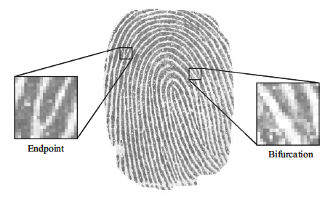

The complete fingerprint consists of about 100 minutiae points while the measured fingerprint contains about 30 to 60 minutiae points, which varies with the size of the finger and sensor. Hence, by measuring and analyzing these points, a fingerprint can be identified. For the extraction of this biometric data from a fingerprint, following steps are followed.

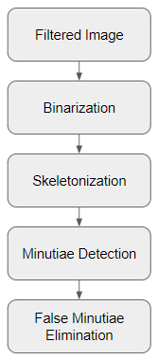

After preprocessing of the image, we get a filtered image with enhanced details and improved appearance, which makes feature extraction easier. Gabor filter is used in preprocessing. Binarization is important step before skeletonization. Greyscale image consisting of 256 grey levels is converted to black and white binary image with the help of thresholding. A threshold value is decided compared to which the pixel values are divided into black or white pixels (1 or 0). These black pixel represent the ridges and white ones are the valleys in the binary image. To extract the minutiae the image must be skeletonized. Skeletonization reduces the thickness of the ridges to a pixel width maintaining the connectivity between them. For the minutiae detection through the skeletonized image, Crossing Number (CN) method is used because of its simplicity. The minutiae are extracted by analyzing the local neighborhood of each pixel in the image of the fingerprint using 8-neighbors connectivity (window 3 × 3).



The value of CN is calculated by following formula –

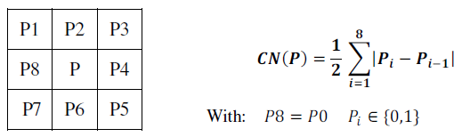

Detection of minutiae also causes the presence of many false minutiae. False minutiae are eliminated based on the fact that the distance between two neighboring minutiae is always greater than certain threshold. This is the standard algorithm for fingerprint recognition. It is used in most of the biometric identification applications. Advantage of this algorithm is the classification of fingerprints, which reduces the number of references. But this algorithm also has some serious drawbacks. It needs the full image of the fingerprints. If the core of the fingerprint is not clearly visible then this algorithm is not efficient. Some applications also requires the detection of partial fingerprints where this algorithm fails.

# Spaced Frequency Transformation Algorithm (SFTA) –

This feature extraction algorithm is used for fingerprint recognition after classification. Fingerprints are classified based on the grouping of the arches, loops and whorls. Fourier transform is an important image processing technique, which helps to convert the spatial domain image to a frequency domain image. SFTA uses the Fast Fourier Transform (FFT) to compare the fingerprints. The output of FFT gives the image in low and high frequency components. Each point in a frequency domain image represents particular frequency in the spatial domain image. Following image shows the FFT of two different fingerprint images –

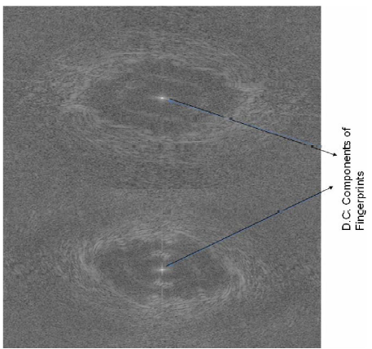

The low frequency components of fingerprint can be seen at center of the above images. The shape, type of swirls and the position of symmetrical points on the figure are the features in the fingerprint image on which the FFT of fingerprint image depends. Any change in these features will also differ the FFT of image and each fingerprint has its unique features, which helps in identification of fingerprints.

With the help of computer, the FFT of two fingerprints are compared pixel wise and the number of similar elements in both images are counted. If the count is greater than certain threshold value then the fingerprint is recognized otherwise it is a mismatch. This algorithm is 99% efficient for full fingerprint images and gives the efficiency of 85% for the partial fingerprint images. The drawbacks of this algorithm are false rejection rate and false recognition rate. The main advantage of this algorithm is the detection of partial fingerprints where minutiae based algorithm fails to deliver. It is used in the intelligence agencies and forensic applications to extract the features of different fingerprint patterns.

# Line Scan Algorithm –

This algorithm is required for the recognition of the line-by-line scanned image of a fingerprint. The line scan algorithm is used to decrease the time taken for comparison by SFTA algorithm. Following is the flowchart of this algorithm –

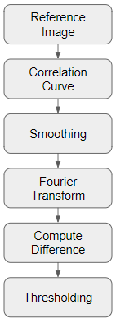

The line scanned image in stored in database and used as a reference for the comparison. The program calculates the boundaries of the images and resizes the image such that the images are of equal dimensions. Correlation curves are plotted which depends upon the features of the pattern in the two images. The correlation curve resembles the row intensities of the compared images. Based on the features in the fingerprints the correlation curves will be same for the same fingerprints and they will differ for dissimilar fingerprints. The curves are then smoothed. The similarity between the curves is calculated in the frequency domain by taking the Fourier transform. The results are then compared to a threshold value to see whether the images are of the same fingerprints. This algorithm shows that the correlation curves can be another tool for the feature extraction process.

LSA gives a high-speed analysis of the fingerprint features as compared to other algorithms. Partial fingerprints can also be analyzed. This algorithm has an accuracy of 95% in case of partial fingerprints and 99% for full fingerprints. The minutiae based algorithms depends upon the distance measurement between the specific points have to consider the changes in the size of the finger. While, this algorithm is independent of the physical dimensions of the finger.

# Discussion –

All these above-discussed algorithms have their own advantages and setbacks. The minutiae based algorithms require higher similarity values for a fingerprint to be recognized. While the modern algorithms like SFTA and LSA can work on partial fingerprints also and they reduce the time taken to analyze a full fingerprint providing a very efficient fingerprint recognition by feature extraction. The major drawback of SFTA and LSA is the absence of pre-classification of the tested fingers which minutiae based algorithm provides. The following table shows the comparison between three feature extraction algorithms discussed in this survey-

|  |  |  |  |
| --- | --- | --- | --- |
|  | Minutiae-based | SFTA | LSA |
| Speed | Slow | Relatively Slow | High |
| Full Fingerprint Accuracy | 99% | 99% | 99% |
| Partial Fingerprint Accuracy | 0% | 85% | 95% |
| Pre-classification | Yes | No | No |
| Size of the finger | Matters | Doesn’t matter | Doesn’t matter |

References-

* S. Mil'shtein, A. Pillai, A. Shendye, C. Liessner, and M. Baier “Fingerprint Recognition Algorithms for Partial and Full Fingerprints”
* Farah Dhib Tatar, Department of Electrical Engineering, National school of the studies of engineer of Tunis, Tunisia “FINGERPRINT RECOGNITION ALGORITHM”
* 1Kulwinder Singh, 2Kiranbir Kaur, 3Ashok Sardana, 4Gulzar Group of Institutes, Khanna, Punjab, India Global Institute of Engineering and Technology, Punjab, India IET Bhaddal, Ropar, Punjab, India “Fingerprint Feature Extraction”